**Cognos Cubes Design**

**Outsales Cube - Sales Team – with Security12**

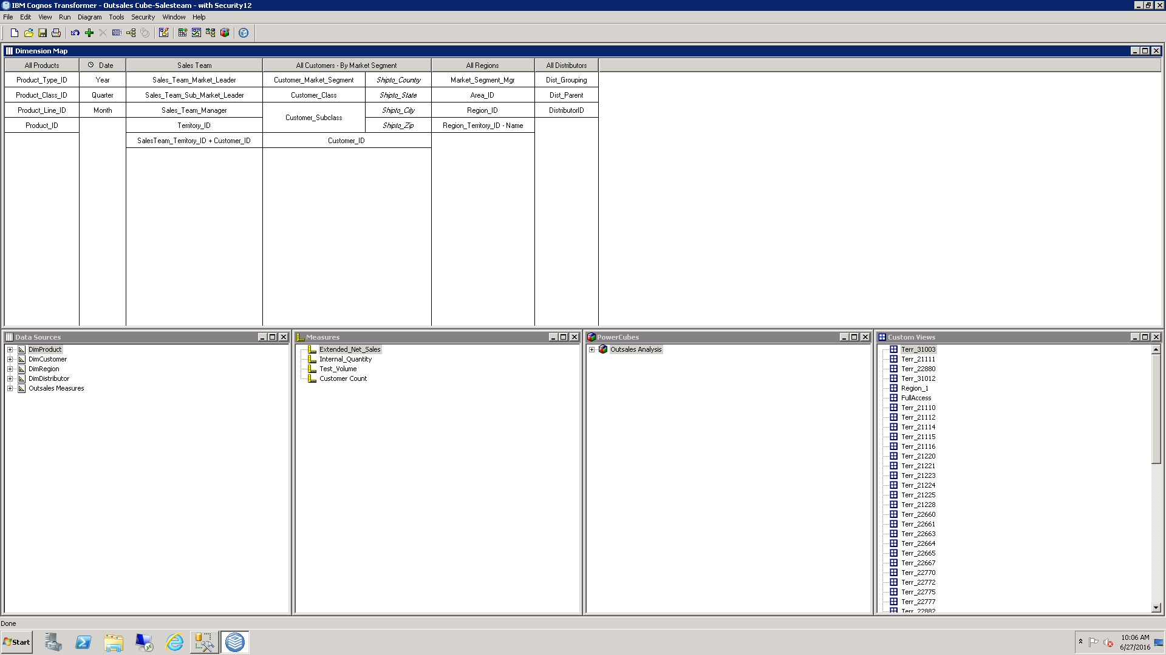

**Outsales Cube – Sales Team – with Security12_V2**

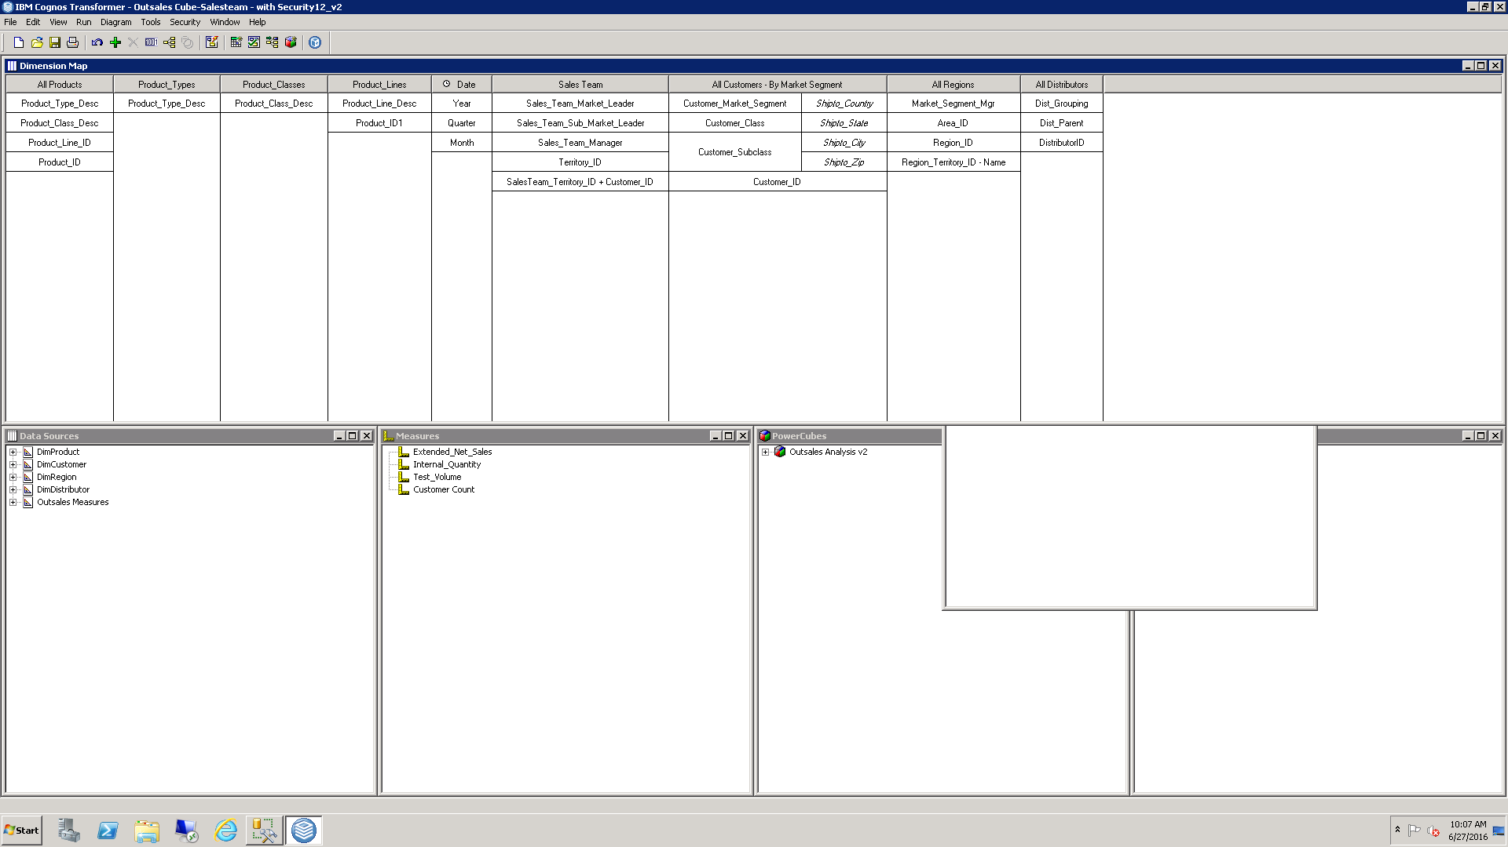

**Finance Analysis_V5**

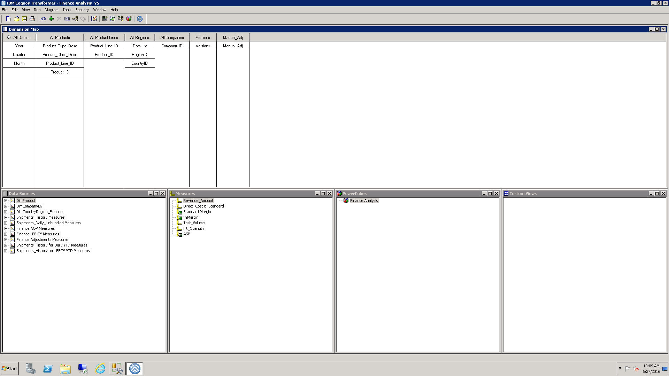

**Finance Analysis – ActualvsPlan_v4**

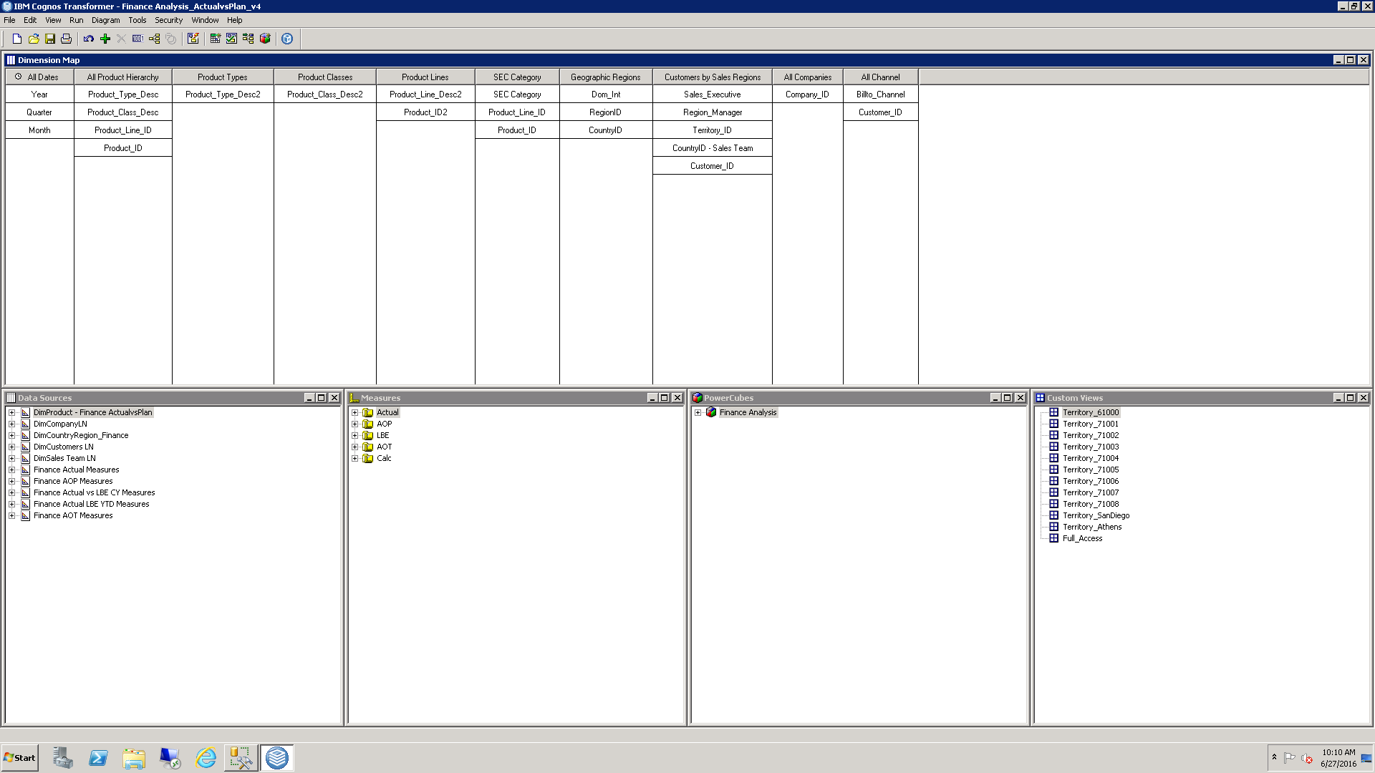

**Finance Analysis – Flash_V3**

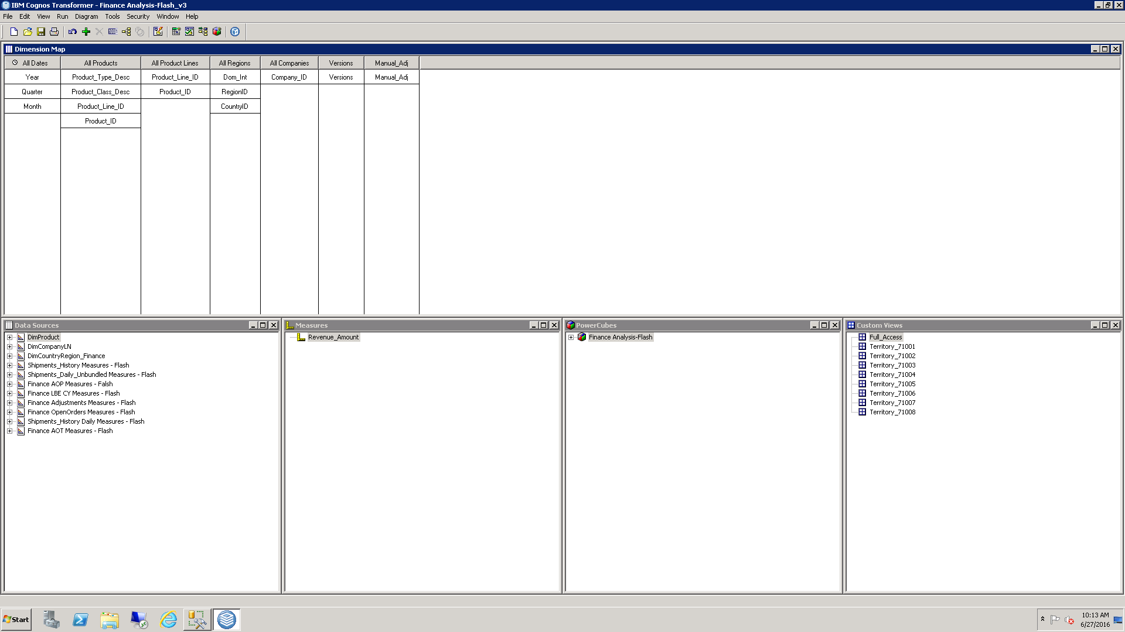

**GL_Costing**

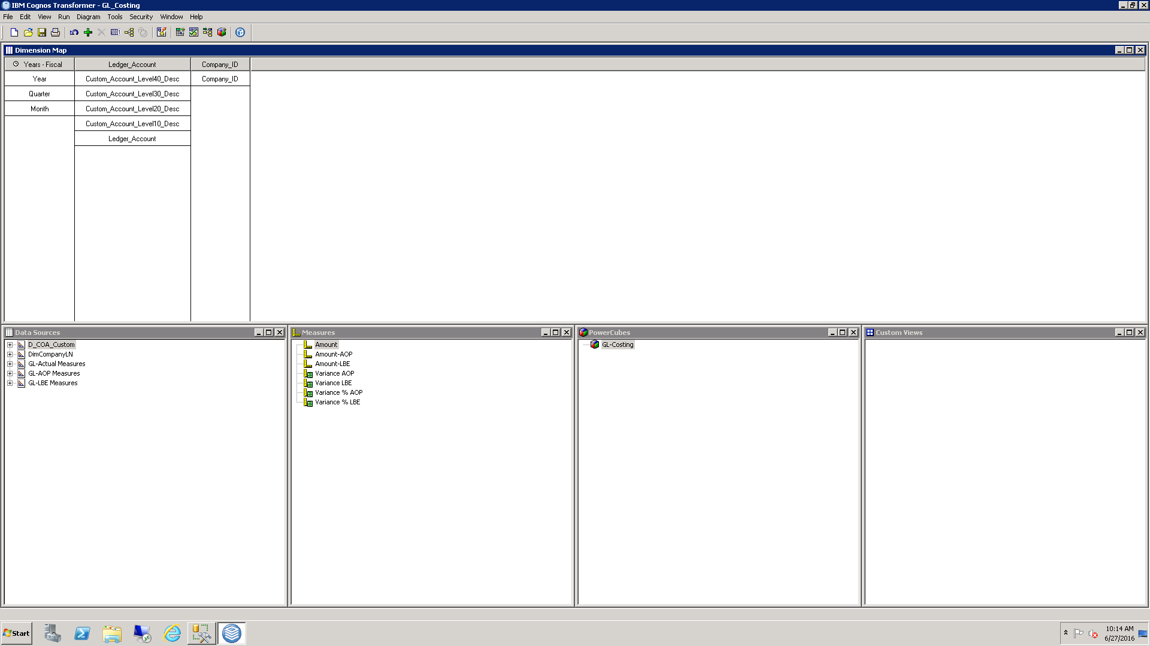

**Complaints_Analysis_V5**

